Discobolus and its reception and appropriation by Nazi Germany

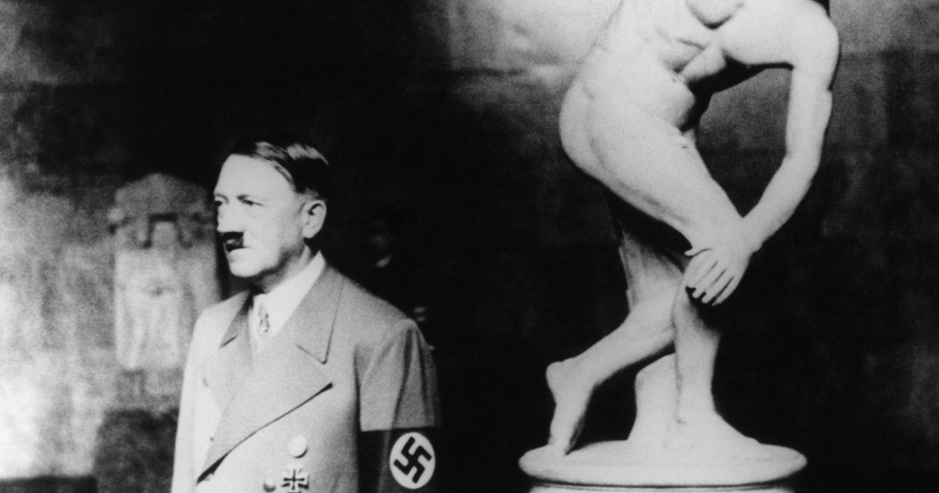

Modern reception and interpretation of ancient sculptures often suffers from a misunderstanding of the cultural and historical context in which the sculptures were created. This can be attributed to passive ignorance in many cases, as it is of course easier to view a sculpture than to learn and comprehend the nuances and details of historical record. However, certain cases of modern reception go beyond passive and into active dismissal of context, particularly to utilize ancient sculpture as propaganda. Intentional ignorance in the context of ancient sculpture is notably a component in Nazi ideology and the white supremacist movements that follow suit. This is exemplified by Hitler’s adoration and acquisition of the Discobolus.

Idealization of Greek and Roman antiquity was an asset in Nazi propaganda. According to this propaganda, the Nazi regime was a return to the ideal and glorious traditions of antiquity; prioritizing beauty, purity, order, and progress. Furthermore, these “truths” about ancient society could be demonstrated by its art, particularly the architecture and sculpture. For this reason, as well as his personal passion for art, Hitler acquired and displayed the Discobolus.

The use of classical art and sculpture as propaganda relies on ignoring many of the facts, both of the art itself and of the overall history. Often, elements of specific sculptural context serve to dismantle the ideas pushed by propaganda. For example, the Discobolus obtained by Hitler, supposed to invoke the glory of ancient Greece and the Olympics, is itself a Roman copy created centuries later. Marble sculptures like the Discobolus were intended to represent and glorify whiteness, ignoring both the prevalence of polychromy as well as the use of materials like terracotta and bronze, the latter itself being the material that composed the original Greek Discobolus.

Broader cultural context also manages to dismiss ideas pushed by Nazi ideology. The recognition of classical art as “pure” in contrast to “degenerate” modern art ignores vast evidence of ideals and norms in antiquity that Nazism would balk at. The attitudes towards sex in both Greek and Roman culture clash with the supposed idea of “purity”; tolerance of prostitution, homosexuality, and pornography exemplify this. This isn’t to say that ancient society was progressive or egalitarian; in fact, the prevalence of sexual abuse and pedophilia in antiquity also disprove the idea of purity in ancient culture. There are numerous sculptural examples that prove this point: representations of male bodies meant to evoke desire in male viewers, androgyny both explicit and implicit in sculptures like those of Venus or Hermaphroditus, satirical depictions of sexual assault (and its subsequent punishment), etc. Even the Discobolus, toted as a depiction of the perfect white male form, appears to follow a tradition of depicting athletic, nude, beautiful men or boys meant to be desirable and erotic, rather than inspirational and ideal.

Classical art and sculpture remains a symbol used by white supremacy, despite clear contradictions in historical context. These contradictions exist not only in the ideology that they’re meant to align with, but also in the ultimate goal of propaganda. Depicting ancient society as prosperous, peaceful, and ideal ignores the problems and downfalls of ancient Greece and Rome. Prevalent violence, systemic sexual abuse, slavery, and disaster were only a few things that rendered life in antiquity far from ideal, even for the ruling class. Ironically, these issues mirror modern society in general but especially the downfalls of authoritarianism and imperialism, the very systems that Nazism and white supremacy idealize and uphold. Ignorance and dismissal of history are effective tools of propaganda, but knowledge and education are powerful counters.